

User Guide
EmSAT Registration System

14th December 2017

Table of Contents
Document History 3
Revisions History 3
Introduction 4
Who Should Read This Document? 4
Enrolling Students in EmSAT Registration System User Guides 5
School Coordinator User Guide 5
EmSAT Registration Student User Guide 7
Conclusion 12

Document History

Author | Date | Version | Comments
Naser Abu Khas | 14-12-2017 | 1.1 | New Release

Revisions History

Reviewer | Date | Version | Comments

Introduction
This document is created to guide “Schools Coordinators” and show them how to use “EmSAT” registration system.
This document provides tour and steps of enrolling students in the system.

Who Should Read This Document?
Schools coordinators are the main audience for this document and any business user who can take their role.
Also Student should read this document to know how to register for exam.

Enrolling Students in EmSAT Registration System User Guides
The school coordinator who will be the responsible one to register / enroll all school students in EmSAT Registration System.

School Coordinator User Guide
To enroll the students in EmSAT Registration System, Schools Coordinators are asked to follow the below steps.
- Read Student Emirates ID using ID Reader
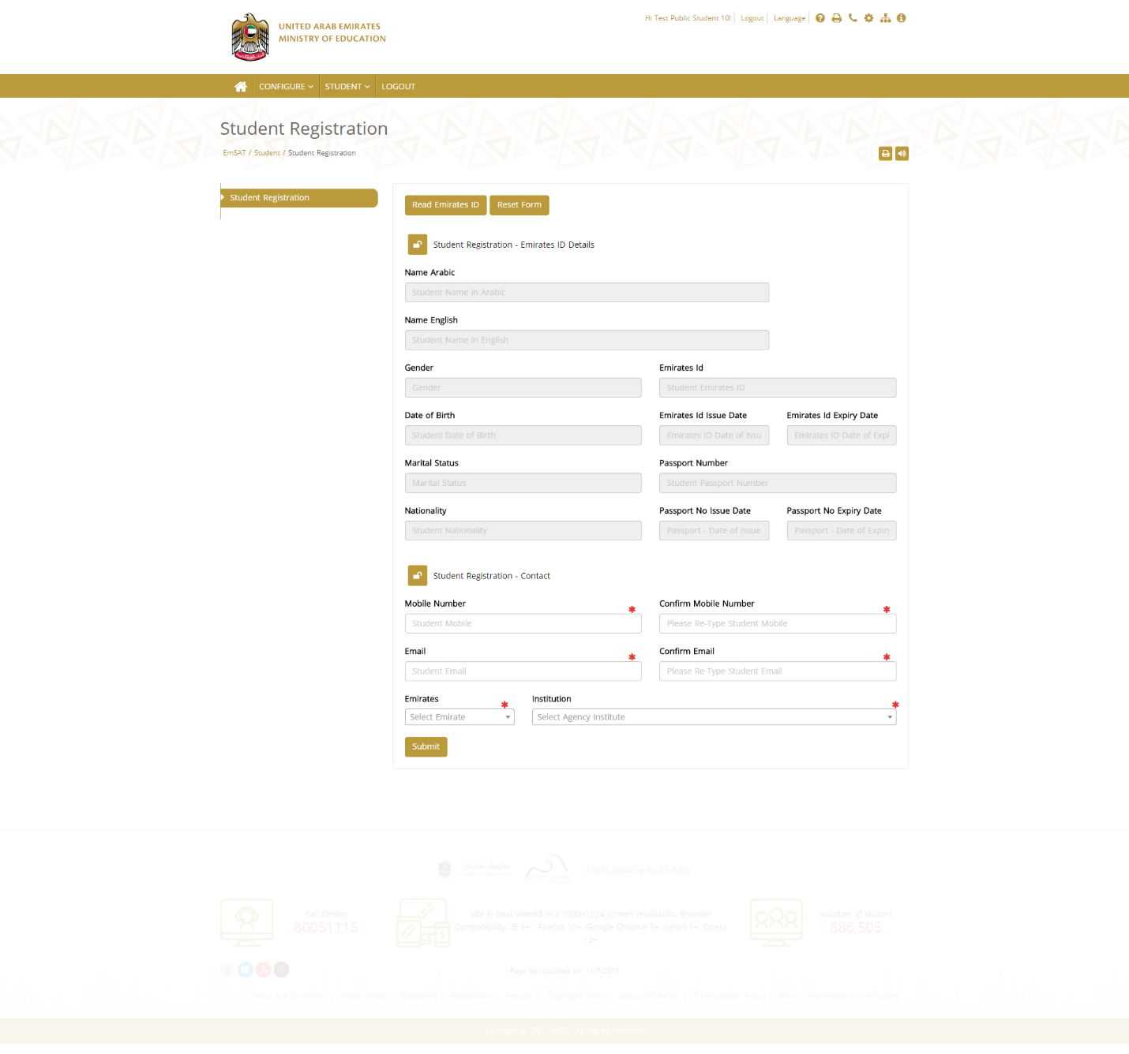Below page shows the form for school coordinator in which he can read the students’ emirates ID.
Figure 1: Student Emirates ID Form

- After reading all emirates id, the coordinator have to enter the student contact details (phone, email) and the institution.
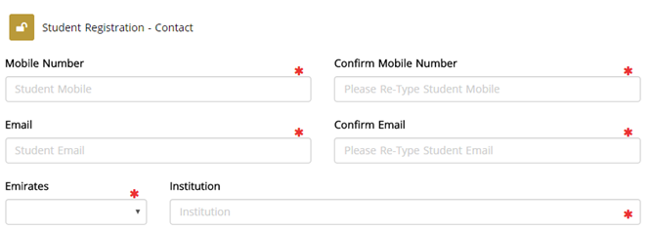
Figure 2: Students Contact Details.

- School Coordinator will submit the form, and the below confirmation page will appear.
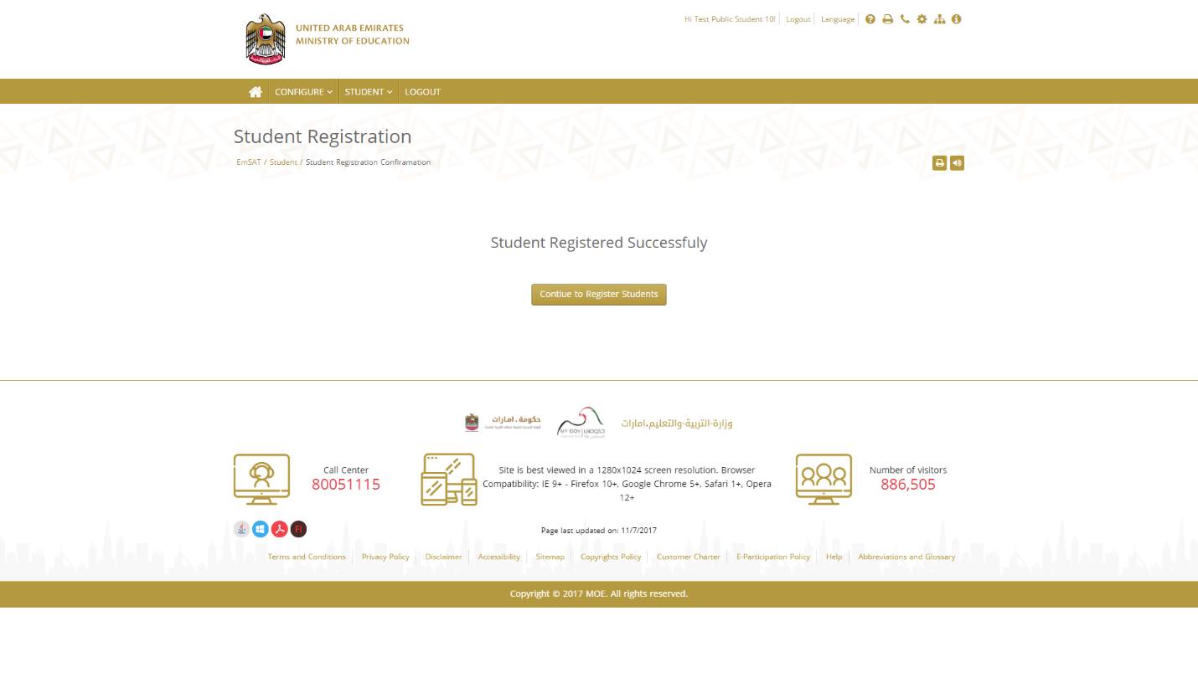
Figure 3: Student Enrollment Confirmation Page.

- System will automatically send email for enrolled student in EmSAT system. After the coordinator registering the students, students will receive on their registered email as the previous process an activation email like the below:
Figure 4: Confirmation Email

EmSAT Registration Student User Guide
Student will be able to register for an exam using EmSAT Registration System and he should follow the following steps:
- Login to his email and find the enrollment notification email from EmSAT system. (See figure 4).
- The content of the email should look like below image:
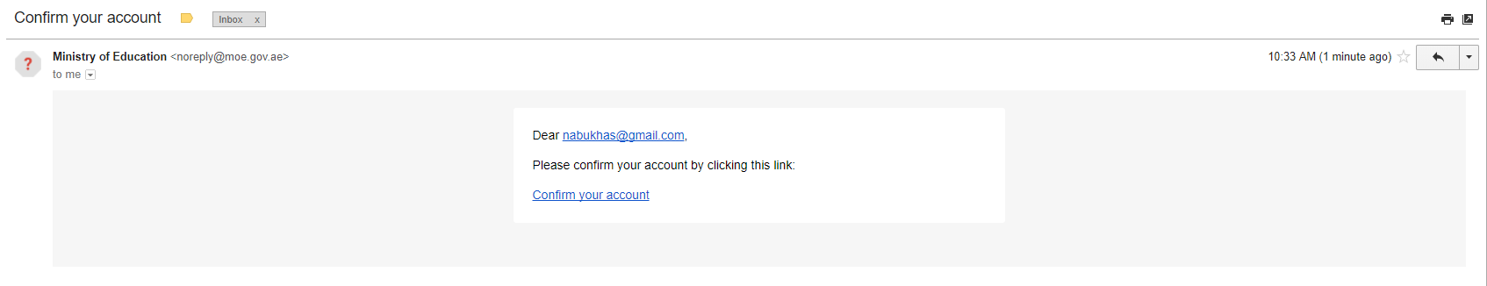
Figure 5: EmSAT Confirmation Email Content
- Student will have to click on the provided link (Confirm your account) to activate the email, phone and changing the password.
- After clicking on the link, the below page will appear to allow the students to activate their mobile number
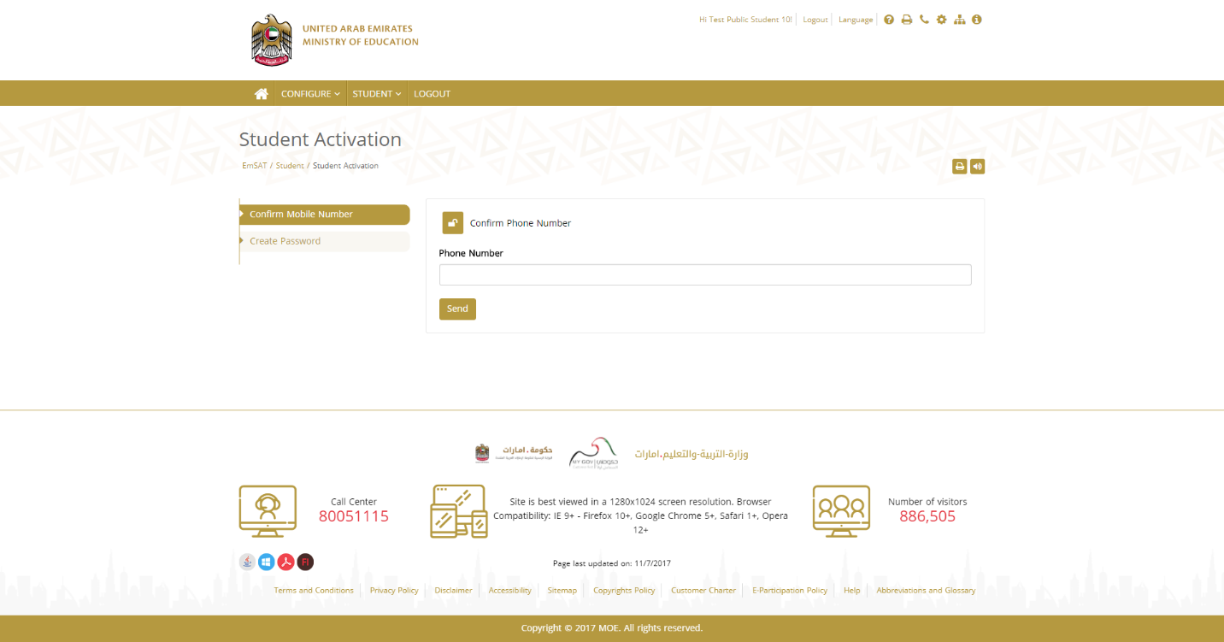
Figure 6: Student Mobile Activation Form
The phone number showing in this page is read only and this number is what actually entered by the coordinator in the registration process.
- When clicking on the send button students will receive the activation OTP on their mobile number and system will wait for entering this number in the below screen:
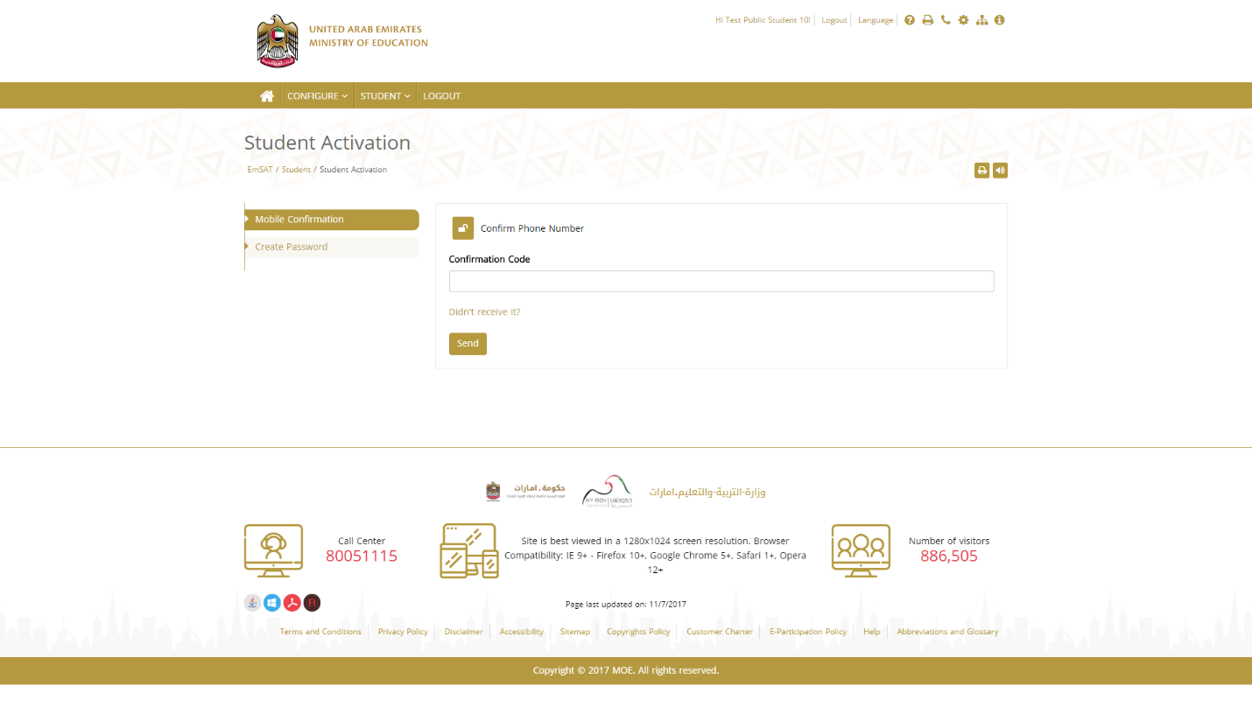
Figure 7: OTP Confirmation Code Form.
The below images showing the activation code received on the student mobile.
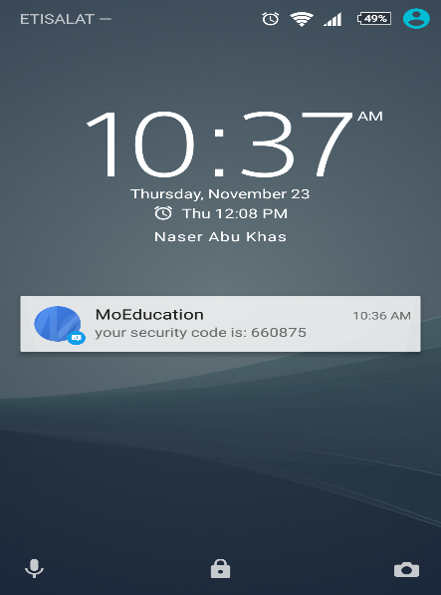
Figure 8: OTP SMS
The students have to enter this number in the screen that ask for the phone number confirmation code.
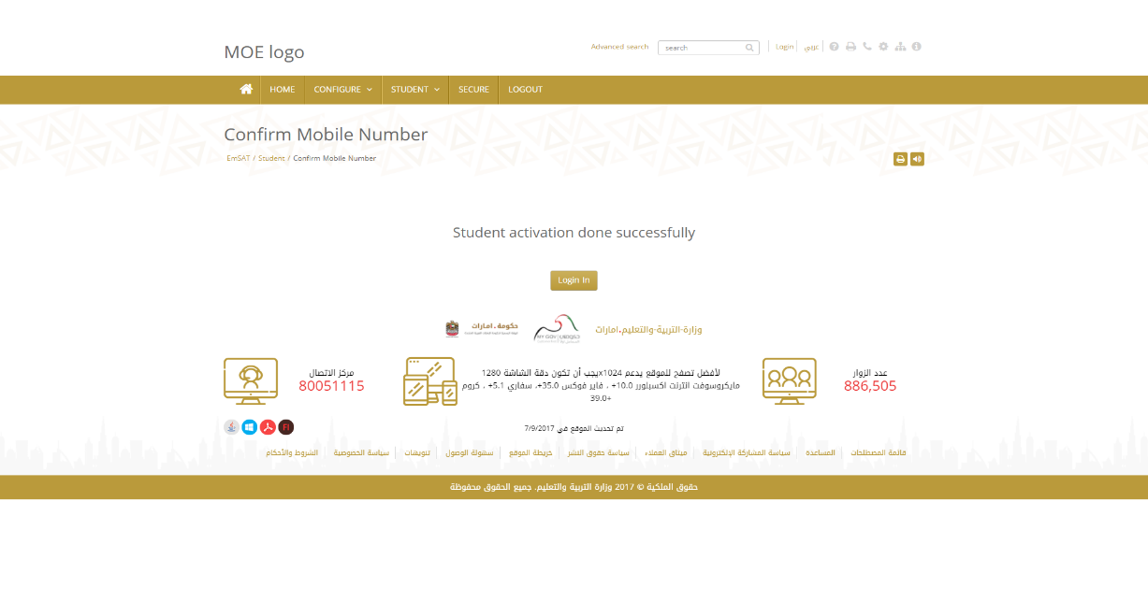
Figure 9: Result of OTP Confirmation.

- After entering the correct activation code the student will be asked to change his default password registered when the coordinator register their accounts.
- After Successful password change, student should login with his/her activated email and the chosen password, and the list of exams will appear to allow students to register for.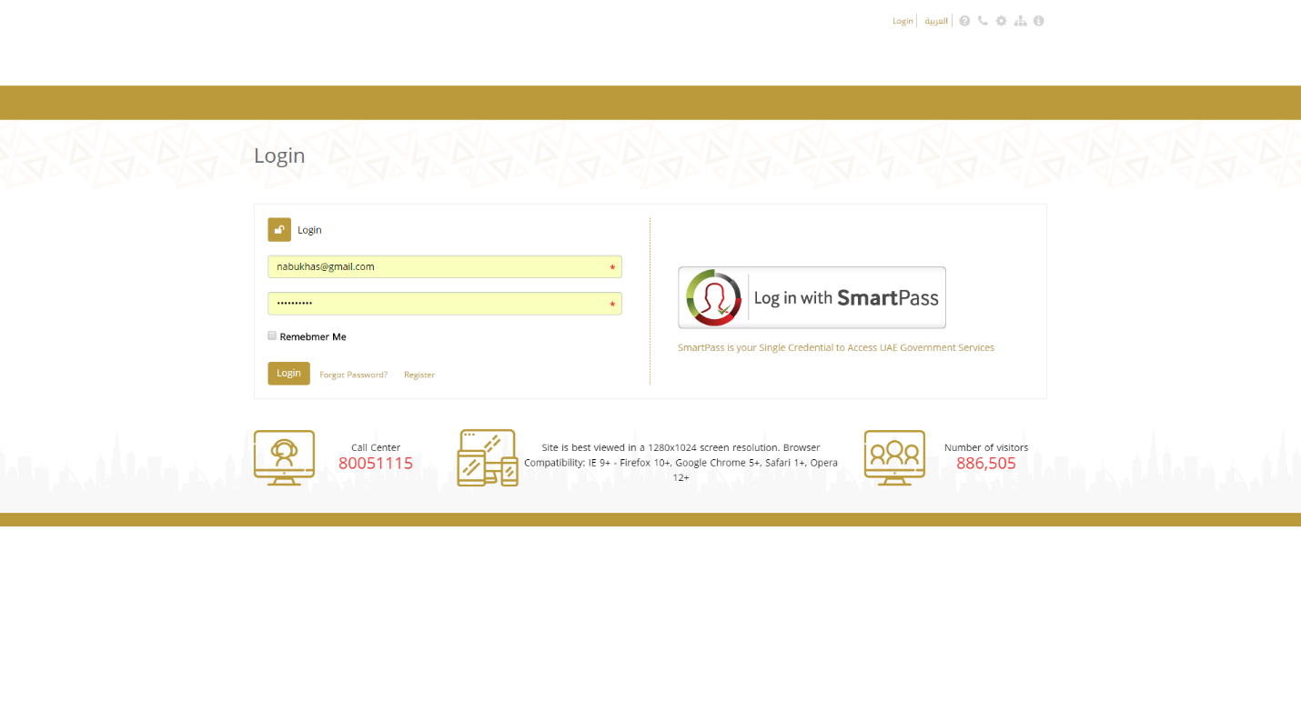
Figure 10: Login Page
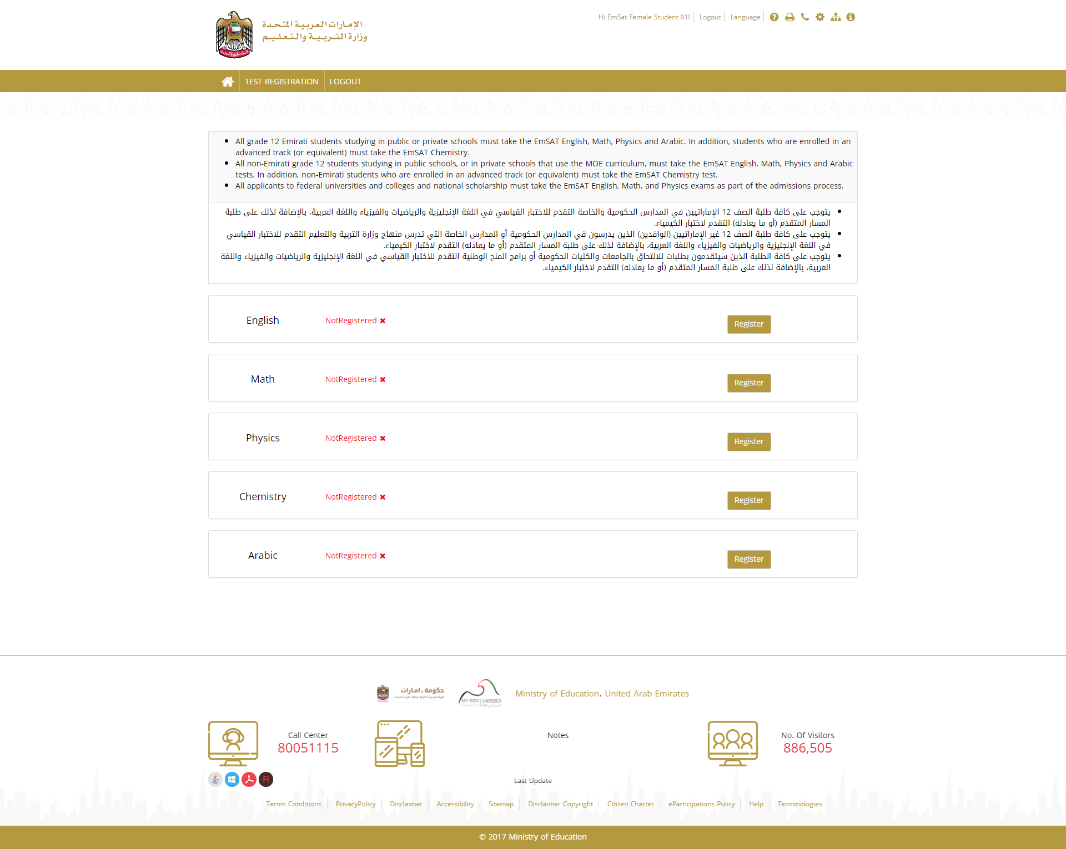
Figure 11: List of Exams
- When student click on register button the below pop up page will appear to allow students to select the test date, center and the time shift.
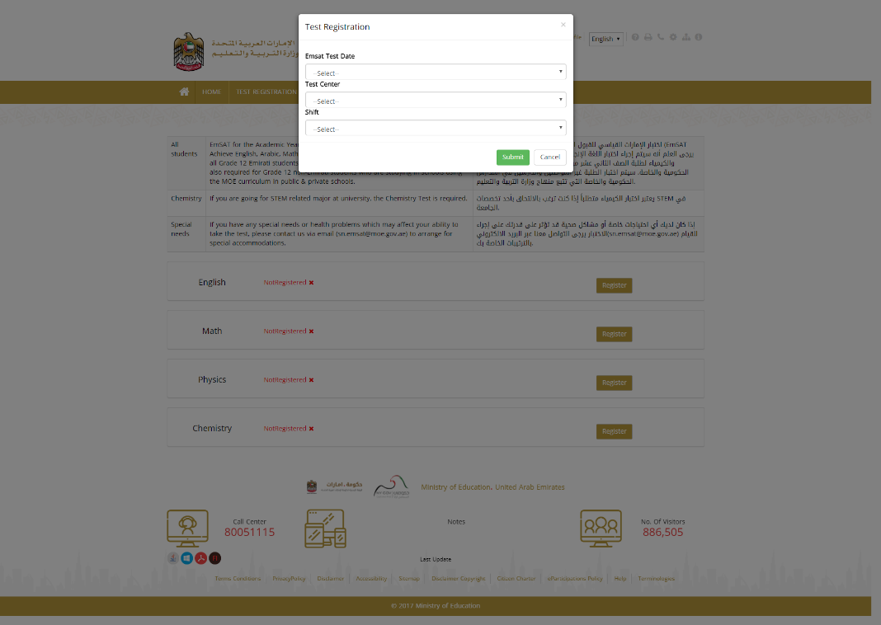
Figure 12: Exam Registration Popup Page
After selecting the fields and submit the form the registration for the test appear as below:
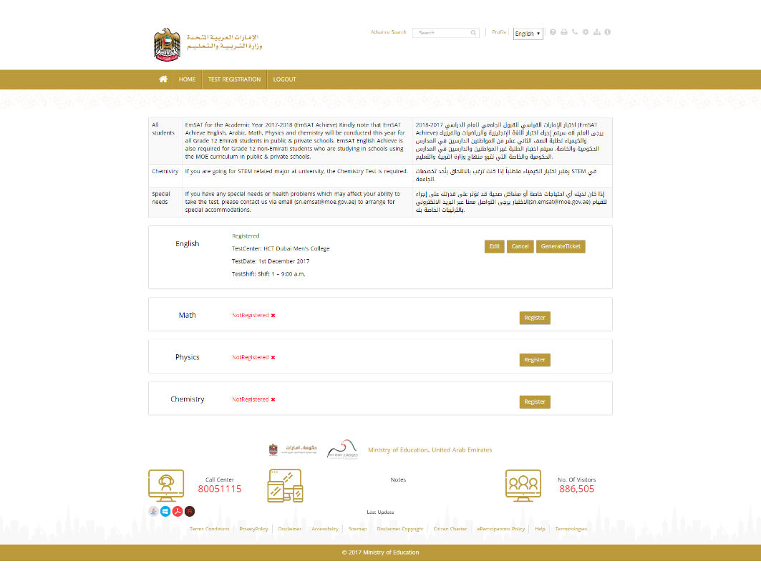
Figure 13: Confirmation of Exam Registration.
- Student can repeat the steps 7-8 to register for another exam

Conclusion
This User guide summarize the steps need for school coordinators to enroll students in EmSAT Registrations system, and shows students the required steps to activate their accounts and register for a specific exam.

